

**CSE 110 Problem Solving – C Programming**

|  |  |  |
| --- | --- | --- |
| **Name** | **:** | M Arjun |
| **Unique ID** | **:** | E0222054 |
| **Year** | **:** | 1 |
| **Quarter** | **:** | Q1 |
| **Department** | **:** | B-TECH CSE (CyS & IOT) |
| **Faculty Name** | **:** | Prof. Balaji Prasath M |
| **Academic Year** | **:** | 2022 - 23 |

1. f(x) = {10x2 -5x+4}, if x<=0

{10x2 +5x+4}, if x>0

Write a program to find the value of the function for given value of x.

**CODE:**

#include<stdio.h>

int main()

{

int x,a,r;

printf("Enter The value of 'X':");

scanf("%d",&x);

if (x<=0 )

{

    a = 10*x*2-5*x+4 ;

    printf("The value of X is %d",a);

}

else if(x>0)

{

    r = 10*x*2 +5*x+4 ;

    printf("The value of X is %d",r);

}

else

{

    printf("Please enter an valid input");

}

    return 0;

}

**OUTPUT:**

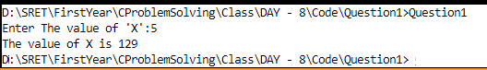

1. Given an integer between 0 and 6, write a program that prints the corresponding day of the week. Assume that the first day of the week (O) is Sunday

**CODE:**

#include <stdio.h>

int main() {

    int d;

    printf("Enter day number (0-6): ");

    scanf("%d", &d);

switch(d)

{

case 0:

   printf("Sunday");

   break;

case 1:

   printf("Monday");

   break;

case 2:

   printf("Tuesday");

   break;

case 3:

   printf("Wednesday");

   break;

case 4:

   printf("Thursday");

   break;

case 5:

   printf("Friday");

   break;

case 6:

   printf("Saturday");

   break;

 default:

   printf(" Sorry, Enter an valid input");

    }

    return 0;

}

**OUTPUT:**

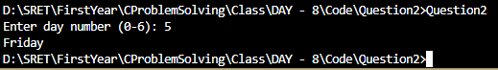

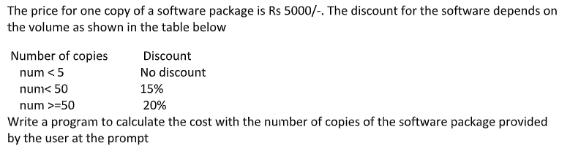

**CODE:**

#include<stdio.h>

int main()

{

int num,perc,price;

float res;

price = 5000;

printf("Enter the no of Copies: ");

scanf("%d",&num);

if (num<5)

{

    res = num*price;

    printf("The price is rs. %f",res);

}

else if(num >= 5 && num<10 )

{

    perc = 10;

    price *= num ;

    res = price - ((float)perc*price/100);

    printf("The price is rs. %f",res);

}

else if(num >= 10 && num<50 )

{

    perc = 15;

    price *= num ;

    res = price - ((float)perc*price/100);

    printf("The price is rs. %f",res);

}

else if(num >= 50)

{

    perc = 20;

    price *= num ;

   res = price - ((float)perc*price/100);

    printf("The price is rs. %f",res);

}

else

{

    printf("Sorry.. Invalid input");

}

    return 0;

}

**OUTPUT:**

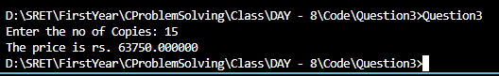

1. 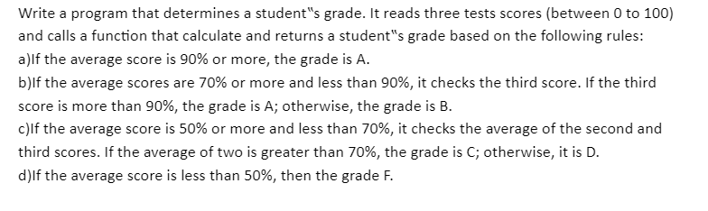

**CODE:**

#include <stdio.h>

struct student

{

    char name[50];

    int roll;

    int res;

    float engmarks;

    float mathmarks;

    float scimarks;

    float totalmarks;

    float Average;

    char studGrade[10];

};

int main()

{

    struct student s;

 printf("Enter The Information of Students :\n\n");

 printf("Enter Name : ");

    scanf("%s",s.name);

 printf("Enter Roll No. : ");

    scanf("%d",&s.roll);

    printf("Enter English marks : ");

    scanf("%f",&s.engmarks);

    printf("Enter Math marks : ");

    scanf("%f",&s.mathmarks);

    printf("Enter Science marks : ");

    scanf("%f",&s.scimarks);

    s.totalmarks = (s.scimarks+s.engmarks+s.mathmarks);

    s.Average = (s.scimarks+s.engmarks+s.mathmarks)/3;

    s.res = (s.scimarks+s.mathmarks)/2;

    printf("\nDisplaying Information\n");

    printf("Name: %s\n",s.name);

    printf("Roll: %d\n",s.roll);

    printf("Marks: %.2f\n",s.engmarks);

    printf("Marks: %.2f\n",s.mathmarks);

    printf("Marks: %.2f\n",s.scimarks);

    printf("Total Marks: %.2f\n",s.totalmarks);

    printf("Average Marks: %f\n", s.Average);

    if (s.Average >= 90)

    {

        printf("You have secured A grade");

    }

    else if (s.Average>=70 && s.Average<90)

    {

        if(s.scimarks>90)

        {

            printf("You have secured A grade");

        }

        else

        {

            printf("You have secured B grade");

        }

    }

    else if(s.Average>=50 && s.Average<70)

    {

        if (s.res>70)

        {

            printf("You have secured C grade");

        }

        else

        {

            printf("You have secured D grade");

        }

    }

    else if (s.Average<50 && s.Average >= 0)

    {

        printf("You have secured F grade");

    }

    else

    {

        printf("Sorry Invalid input");

    }

    return 0;

}

**OUTPUT:**

